**Styling and CSS components:(20)**

* **CSS stylesheets**
* **Inline styling**
* **CSS Modules**
* **CSS in JS Libaries**

**CSS stylesheets:**

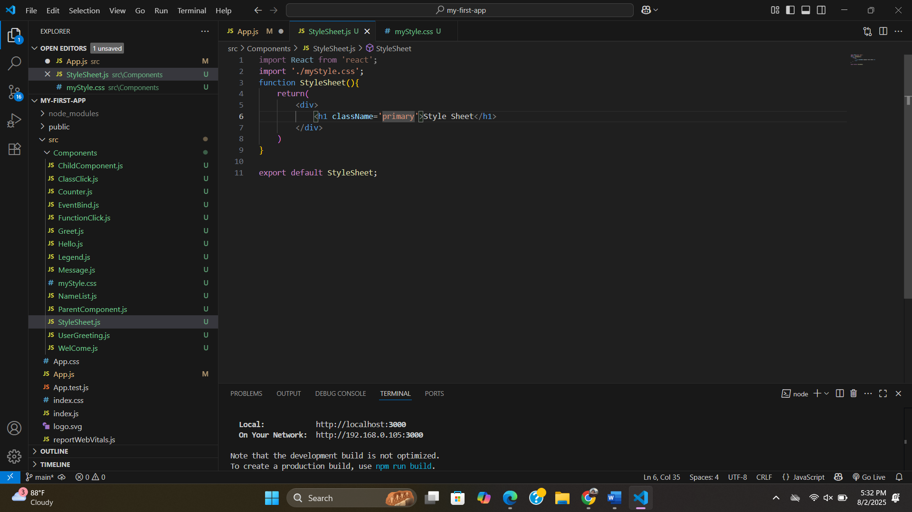

**Can also use props:**

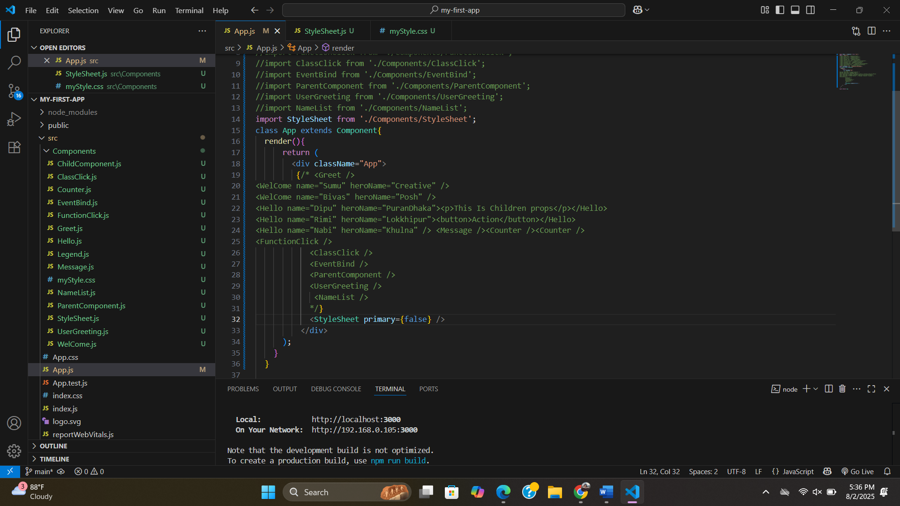

**Multiple classes:**

**Inline styling:**

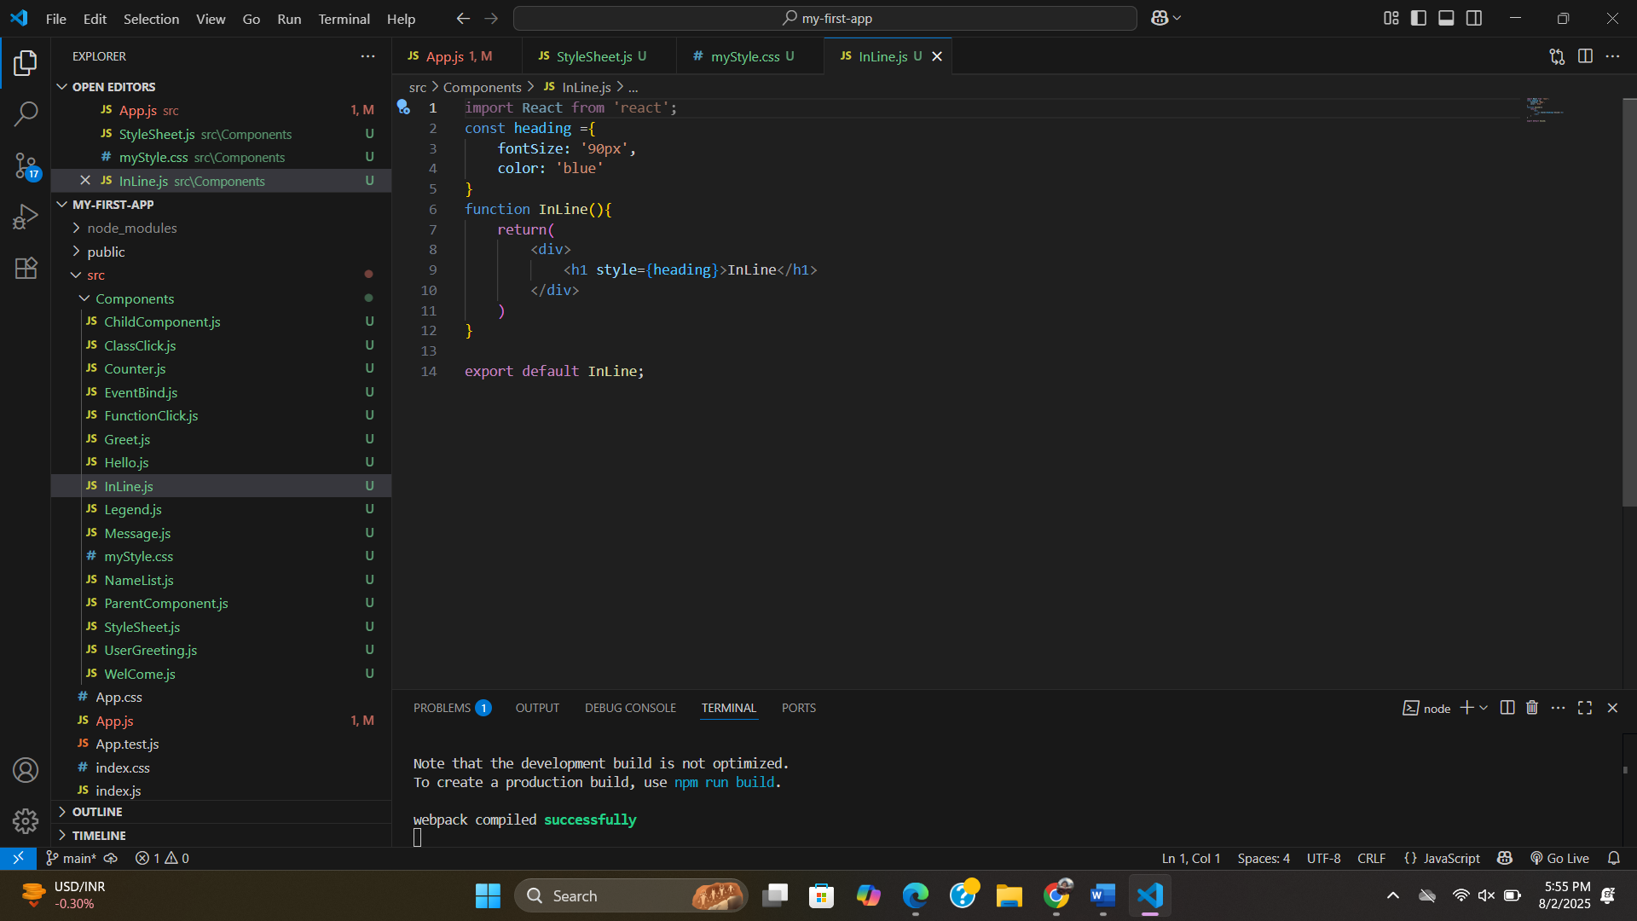

**CSS Modules:**

you have to open the green two .css files.

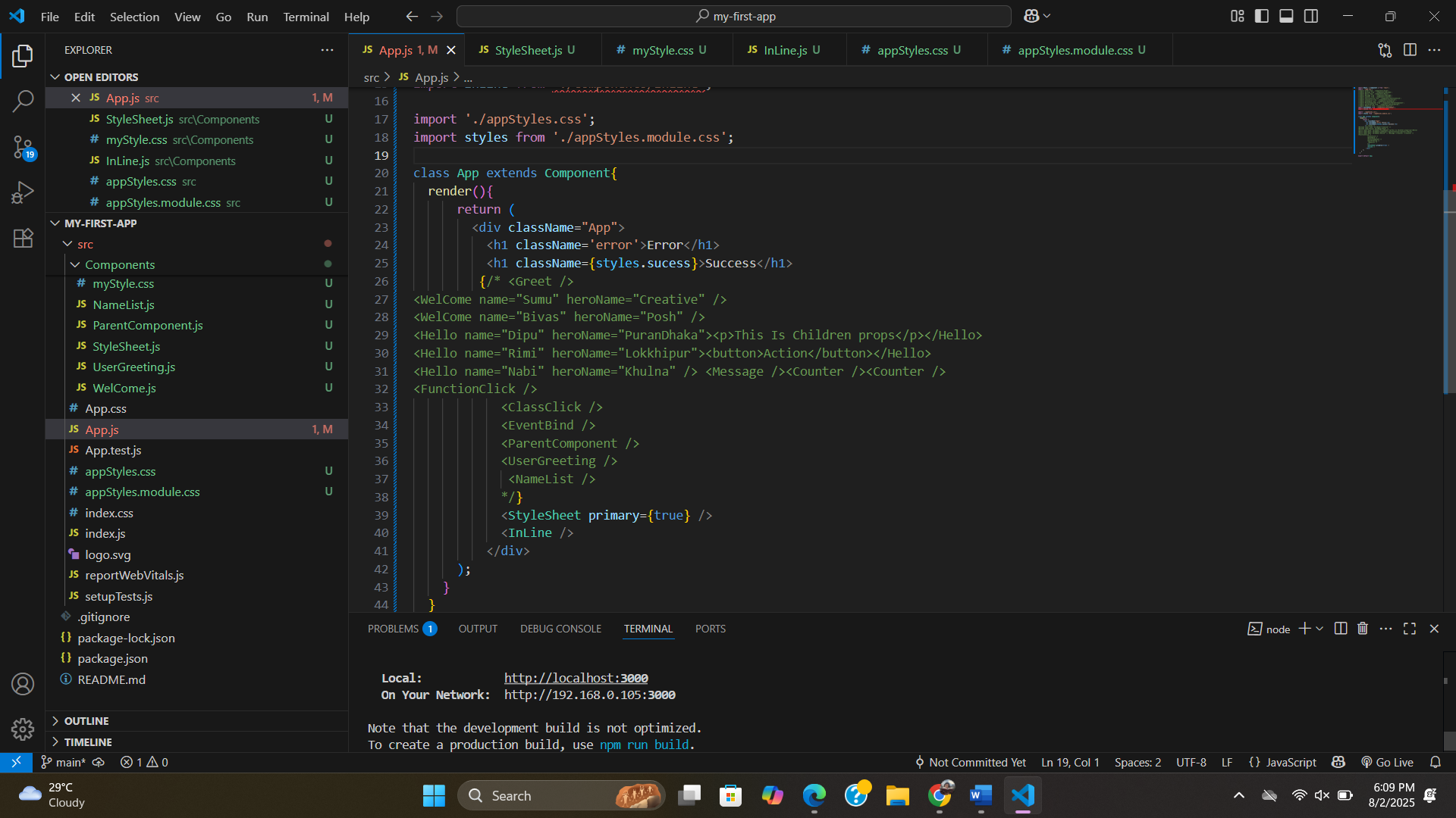

#.module.css doesn’t works for all classes.but .css works all classes.